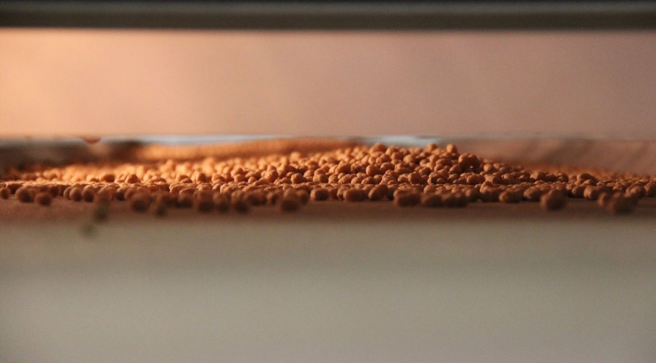
Oat protein in new applications
In cooperation with the Danish Technological Institute, Swedish Oat Fiber, now owned by Naturex, has developed new extruded snacks on oats. The next step is the utilization of extruded oat proteins as an alternative to soy in plant-based alternatives to meat.

Access to pilot facilities provides flexibility
Extruding is a process that, with a combination of mechanical and thermal processing, changes a raw material into a new exciting structure, texture, taste and color. Thus, it should be investigated how oat fractions behave when extruded. Development and testing as well as pilot production of customer samples took place at the Institute of Technology of Biomass.
We chose a collaboration with the Danish Technological Institute because they are an independent partner and they can run small series with their food extruder. This way, one can try out and do many trials in one day. It provides a high degree of flexibility in terms of time and raw material costs, says Jette Bergwall, Sales Director at Swedish Oat Fiber.
In addition to the actual development work, the collaboration has also created value in the marketing phase: Access to the pilot plant has enabled us to hand out samples to our customers without having to invest in expensive production facilities. That is a clear advantage, explains Jette Bergwall.
Good response from the market
The extruded snacks have now been presented to Swedish Oat Fibers customers at the Snackex show in Vienna 2017. The response has been overwhelming: Today we have more customers who are running experiments with the raw material. They have clearly been ready for something new. We look forward to seeing the first products in markets, says Jette Bergwall.
Alternativ til soya i plantebaserede alternativer til kød
Swedish Oat Fiber is seeing more opportunities for their raw material in the future. This is especially true for the upcoming trend of using vegetable proteins as an alternative to meat. Here, oat proteins are expected to play an increasing role.
Jette Bergwall, Sales Director at Swedish Oat Fiber, explains the background here:
We see great opportunities in the utilization of textured oat proteins as an alternative to soy. Soya does not always give the right flavor, there may be consumer challenges with the GMO issue and also with the climate change. We therefore need to proceed developing the concept in cooperation with Danish Technological Institute.

